CRITICAL TIME!—Coming Financial Changes—Israel
December 7, 2017
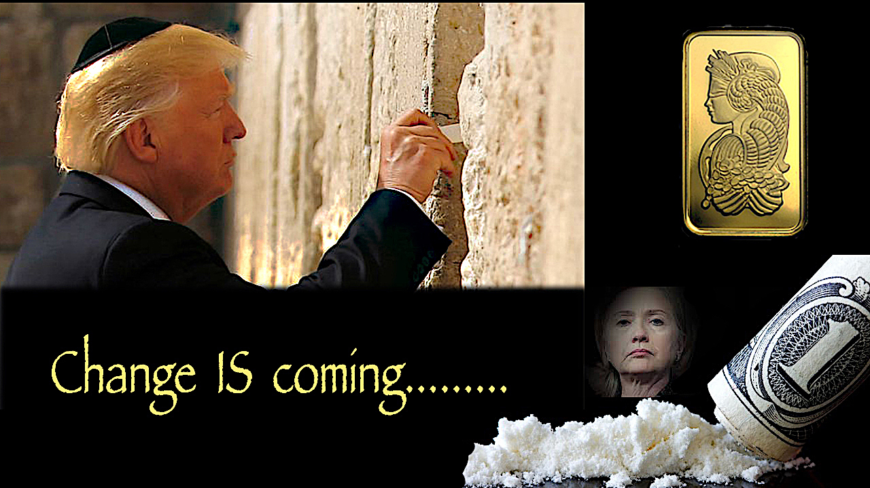
Lord Jesus, please impart to all of us the absolute critical condition of our nation and the need for deep intercession and fasting. Jesus, deliver us from evil, deliver our president, our nation and the world. Amen

My dear Heartdwellers, I knew I would have to bring this news to you soon, along with the progress of those criminals in our government who are in the process of being exposed.

But I have to say, I am not a news channel, nor do I wish to be involved in news or conspiracies or anything of the like.

But the Lord has asked me to touch it lightly from time to time.

So, the information I am sharing with you comes from a very credible source, high up in the military—who, when he sees things on a news channel or the like, recognizes top-secret disclosures in the media. Because of this ability to discern truth from error, due to his position in the government. We have quite a bit of information released by different media outlets that happens to be classified and has been leaked by those persons in the news who are actually CIA agents, working against our nation.

That said, your prayers are REALLY working. Praise God! Don’t think for one moment you are 'just a little soul' praying. As a matter of fact, the littler you are, the purer you are, the greater the weight of your prayers for our nation—for Our Heavenly Father loves the humble, the meek, the little and the pure.

So, do not slack off on your prayers, or get it in your head that you're just a little person praying. All these prayers are having a dramatic impact on what's going on in our nation right now. Our Heavenly Father loves the humble, the meek, the little and the pure. So, don't slack off on your prayers.

The Lord called us to prayer and fasting six days ago. At that time, I had stumbled upon a piece of news—which is most unusual for me, because I avoid it. But this night, I felt the Holy Spirit tapping me to pay attention.

It was an article by Hal Turner, someone I didn’t know. But what caught my attention was the assault on CIA headquarters. His sources said they never left their helicopters, while witnesses said they had landed on the lawn. Hal also said that they were just doing a show of force. When I thought about it, I thought, that didn't make any sense to me. It was on a Saturday. Because that would give the CIA all the time in the world to destroy evidence—so I figured we were not getting the truth.

So, I went to my military source. He is a Heartdweller—very devout, and a Prayer Warrior. And told me that not only had they landed, but they confiscated all kinds of documents incriminating a large amount of people in the government and the media.

The Lord also confirmed that’s what happened and called us into prayer and fasting to protect the president and pray that the criminals would indeed be revealed and be brought to justice. My particular prayers were that the fake media MSM (that is the Main Stream Media), would be laid bare and exposed.

Since we have been praying, one well-established reporter was found to be on the CIA payroll, as many others are in the conspiracy to discredit our president and destroy our country. Another newscaster was fired and the list of sealed indictments is now OVER 5,000.

Really, I think they will have to build another jail to hold all the traitors.

Here is an update today, 12-6-17, on what has transpired since we started praying six days ago, when the invasion of CIA headquarters took place that previous weekend.

And this is by no means comprehensive. I don't get the news and all kinds of other things could be happening. But know these things are happening because of our credible source, and I wanted to share it with you.

"The Marines have proof that Bush 41 ran the CIA operation that killed JFK. That Hildebeast Clinton had Vince Foster and JFK Jr. killed. That Hildebeast stole 20 million votes and 6 states. That Obama was born in Kenya and Senator Cruise was born in Canada. That Gore won the 2000 election and Bush stole votes in 6 states to win. They know who ran 9/11 and it was an inside job. They also know who in the MSM Main Stream Media are on the CIA payroll (big names).

"The Marines also know who the pedophiles are in the US, China, and Europe. Putin took care of (executed) the Russian pedophiles, which is one of the reasons Russia is the target of the MSM scorn. It's coming to a head, it should be an interesting two weeks." My source said.

He continued to talk about the financial situation.
"We're coming to a critical point here, where things are about to turn over. At least, we believe that."

He continued, "I personally would never buy crypto currency. We have gold and silver. We have some in savings and checking. When the crash occurs, stocks and bonds will take a serious hit. The gold standard, real money, will replace Federal reserve notes.

"Laundered money must be reported, which will kill the freedom of crooks, so laundered money will disappear. Trump and the US Treasury have seized $100 trillion Deep State dollars so far and have destroyed hundreds of CIA-run opium factories in Afghanistan."

Wow!

"Congressional drug use will be the next scandal, many will resign or not run again." And that's the end of his report.

Well, this is already old news, according to what's happening so quickly. But I wanted to let you know your prayers are moving Heaven and Earth to get this whole situation cleanup up.

Now, I need to tell you that the Lord has instructed us to buy gold. We have very little money, so we can’t buy a bunch by any means. So, I thought that gold was only available in one-ounce amounts, which is...oh, $1,300 an ounce right now. I think a lot of people are under that impression, too. But the good news is, you can get some—from Walmart, believe it or not—you can buy it from Walmart for, oh—$58. You're not getting as good a deal, but they have several different ways that they market gold. So, you're not stuck with having to spend over $1,000 to get gold. There are smaller quantities that you can buy. I just wanted to let you know that, because I didn't know it myself. So, I'm going to follow the Lord's advice with what little we have to do that.

The information from our source says that it is very likely the crash everyone has been waiting for will happen January 1, 2018. If it does, the Federal Reserve will be shut down, and all the money you have in the bank will vaporize along with retirement funds and stock investments and perhaps bonds.

I don’t really know how this works. I am just relaying the information to you. There will be an interim system that President Trump will use to smooth the transition. But the Deep State is going to try and pin all of this on him, and say that he's responsible for the collapse.

"The chatter suggests that Obama and his Deep State cronies are going to try and divert attention away from their crimes so they can “blame” President Trump for a collapse in the economy. Most Americans are not well read enough to know better, because they are feeding off Main Stream Media Liars." (from the source)

So, with what little we have, we are paying our bills as best we can a little ahead so we don’t lose anything. And taking the rest to pool with a group to buy gold. The possibility is that Trump will set the gold standard at 5 or 10 thousand dollars an ounce. That means that a little group who invested get back in return one or two thousand per person.

That means we can still feed the poor and pay their electric bills as needed and send money to Nicaragua for latrines and water systems to help and improve their living conditions. Because they get so sick.

Now, I HAVE NEVER been told to do anything like this before, Heartdwellers. Never. I am not shifting my reliance on the monetary system, by the way. I am obeying the Lord, who knows everything that needs to be known about what will soon take place.

So, I want you to understand that this is not a change in our approach to our faith, AT ALL. I began speaking to the Lord.

Oh Lord, my heart is so heavy for those who are going to suffer so much from this. Especially the elderly. So much is going to be so terribly disrupted. Please, Lord, please—mercy.

Jesus began, “It will not happen all in one day. Just like the real estate crisis, it will begin in one day and end in one day, several months later.

"This is part of My cleansing of this nation. This is a wakeup call to My people who are sitting on the fence. It is time to get your souls in order. This is not just about money, it’s about a decadent people who have forgotten Me. No longer will one group of Christians be alive and the other dead."

Spiritually, that is.

"Rather, this will shake the death and lukewarmness out of them, to wake up, pay attention, and respond to Me.

"It will not be all that disastrous, as you first thought, because it is true: your president is expecting this and has prepared for it. This will not take him by surprise.

"Although the media will attempt to blame him, that won’t last long as more and more of the corrupt media and politicians are brought to justice. This will not stop him from bringing these criminals to justice. It will confuse people, but only for a short time.

"It is the praying Christians who will hold this nation together."

Guys! The Lord is counting on us. We can't let Him down.

"Oh, My heart aches for those who do not know better," He continued, "and have been so lazy, refusing to read the signs of the times. Oh, how I ache and hurt for them. It truly is a harsh measure to bring them into a state of awareness, for they have chosen to sleep though many things they should have been aware of.

"This, unfortunately, goes with the middle-class liberal lifestyle, as well as the elderly retired who didn’t rock the boat but just fit into the mold of conformity, counting up their retirement benefits.

"Families will be called upon to support their own elderly, putting a new burden on them. This also is by My design, to wake them up from a selfish lifestyle and draw them into hearts of charity and caring, even as the Scriptures advise.”

”'Honor your father and mother'—which is the first commandment with a promise—'so that it may go well with you and that you may enjoy long life on the earth.' Ephesians 6:2-3

"Clare, this is only temporary. Everything will bounce back in a few months; timing depends much on your prayers. All of your prayers.

"I do not want you to have the idea that this is the end. It is NOT the end; it is a temporary adjustment and correction to a society of materialism. You will recover, all will recover, but it will be a difficult transition.

"I just want you to be prepared to do what you can for all involved and to keep this mission afloat while the transition is taking place. There will be a resurgence of holiness and prosperity that, if handled well, will last quite a season.

"However, if people begin to forget Me again, that will be the beginning of the end.

"I want you to be encouraged." Jesus continued. "I want you to encourage others, along with the warning. There are several steps they, too, can take.

"First and foremost is prayer and support for your President—he will not lead you astray. He will lead you out of this collapse if you pray and follow him. Encourage others to follow him and to stay in prayer. Much will depend on how much you stay in prayer, fast, and give.

"The dangerous place to be during this transition are the big cities, but there is not going to be the kind of rioting and pandemonium you imagine. It is going to be a slow, increasing depression until the system rights itself. It will put a hole in the president’s economy, but it is going to bounce back.

"As I have told you before. Rest in Me. Trust Me. It’s not going to be as traumatic some have presented it, who want to sell their schemes."

There's a lot of that on the Internet.

"Nevertheless," He continued. "Turning your cash into gold is still the right thing to do until the system rights itself."

And just as I was preparing to record this, which you probably already know: In an extremely inflammatory move, as far as the Muslims are concerned, President Trump proclaimed Jerusalem the capital of Israel!

Hallelujah! It's about time!

And, dear Heartdwellers, just a little while ago this quote came in and I checked it on the Internet. And it is accurate according to some sources.

It says, "A stunning Ministry of Foreign Affairs (MoFA) report circulating in the Kremlin today detailing the agenda of Foreign Minister Sergey Lavrov and US Secretary of State Rex Tillerson for their meetings tomorrow in Vienna, during the summit of the Organization for Security and Co-operation in Europe (OSCE), states that the “priority item” heading the list for discussion is President Donald Trump’s “declaration of war” (this is what they're calling it.) decision to recognize Jerusalem as the capital of Israel—and reveals that Trump had previously related to President Putin that he had no choice to do, as he needed “divine protection” to protect himself and his nation from “satanic forces”—and who bluntly warned: “Either God will win, or I will die”.

And that quote I've taken from “WhatDoesItMean.com.” But it's in several other places, too.

Back to our knees, Heartdwellers! The cat's out of the bag. This has been a Satanic nation since the 60’s and even before, but now the Deep State is being exposed and prosecuted.

Pray, pray, pray for our President and Nation!

And thank you for being faithful to take care of our needs, so we can continue to do what the Lord has called us to do.

Bless you and thank you.

